Code Usage Consent Agreement
This agreement is made on 03/07/2025 between the following parties:
- Sergio Cantillo Blanco referred to as “the User”, and
- Carlos Cerdá Morales, Loubna Founoun ElAoud, José Luis Moraza Vergara , Claudia Oviedo Govantes referred to as “the Contributors”.
Purpose:
The Contributors agree to grant the User permission to use the source code they have authored for academic purposes related to the project entitled Acme-ANS, submitted as part of the coursework for the second call of the subject Diseño y Pruebas II.
Terms of Use:
- The granted code may only be used for academic and non-commercial purposes.
- This agreement does not transfer any intellectual property rights beyond the scope of this academic use.
Signatures:
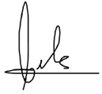
Carlos Cerdá Morales
Date: 03/07/2025
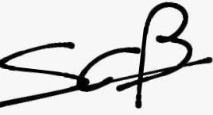
Sergio Cantillo Blanco
Date: 03/07/2025

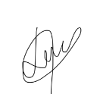
Loubna Founoun ElAoud
Date: 03/07/2025
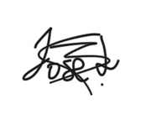
José Luis Moraza Vergara
Date: 03/07/2025

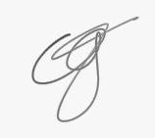
Claudia Oviedo Govantes
Date: 03/07/2025

